第三单元全练全测
基础全练全测
一、【四会词汇】写出下列单词的过去式及汉语意思。(24分)
1．watch
2．wash
3．clean
4．play
5．visit
6．do
7．go
8．read
二、【四会词汇】根据所给汉语意思写出相应的英语单词或短语。(21分)
1．上一个 ____________________
2．周末 ____________________
3．向；朝 ____________________
4．公园 ____________________
5．去游泳 ____________________
6．去钓鱼 ____________________
7．去郊游 ____________________
三、【三会词汇】根据所给英语写出相应的过去式及汉语意思。(16分)
1．cook________________ ________________
2．study________________ ________________
四、【二会词汇】给英文单词或短语选出正确的汉语意思。(15分)
( )1.yesterday ( )2.tongue twister
( )3.fly ( )4.return
( )5.swim
A. 飞 B．游泳 C. 昨天 D. 送回；归还
E．绕口令
五、【四会句子】为下面的句子选择正确的汉语翻译。(24分)
( )1.What did you do last weekend?
( )2.I visited my grandparents.
( )3.I played football.
( )4.What did you do yesterday?
( )5.I went hiking.
( )6.Did you read books?
( )7.Yes，I did.
( )8.No，I didn't.
A．昨天你做什么了？
B．我去郊游了。
C．是的，我看了。
D．上个周末你做什么了？
E．不，我没做过。
F．我去看望过祖父母。
G．你看书了吗？
H．我踢了足球。
综合全练全测
听力部分(40分)
一、听录音，选择你所听到的单词。(10分)
( )1.A.stay B．test C．fail
( )2.A.cake B．fly C．laugh
( )3.A.soon B．skirt C．trip
( )4.A.longer B．shorter C．stronger
( )5.A.feet B．meet C．know
二、听录音，选出你所听到的句子。(15分)
( )1.A.How old is Amy?
B．How are you?
C．How do you feel?
( )2.A.What did you do yesterday?
B．I went to a park.
C．Did you play chess?
( )3.A.I listened to music.
B．How about you?
C．Did you go to a park?
( )4.A.Did you go last night?
B．Did Alice play the piano?
C．What did you do last night?
( )5.A.I like the yellow dog.
B．Today was a fun day.
C．It was a windy day.
三、听录音，给下列句子排序。(15分)
( )1.I played football last Thursday.
( )2.My mother goes to work by bus.
( )3.He is a bad man.
( )4.Did you go swimming last Sunday?
( )5.Let's go hiking together.
笔试部分(60分)
四、根据所给图片，写出短语。(8分)
1. INCLUDEPICTURE "F:\\word资源\\2011x全练六年英语下人教版PEP\\QLYYRP6X28.TIF" \* MERGEFORMATINET 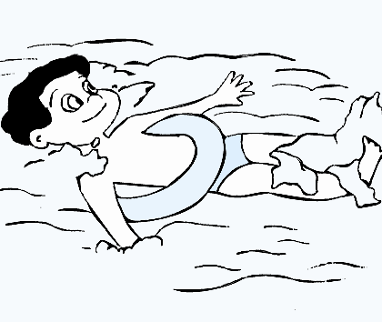____________
2. INCLUDEPICTURE "F:\\word资源\\2011x全练六年英语下人教版PEP\\ZM28.TIF" \* MERGEFORMATINET ____________
3. INCLUDEPICTURE "F:\\word资源\\2011x全练六年英语下人教版PEP\\QLYYRP6X29.TIF" \* MERGEFORMATINET 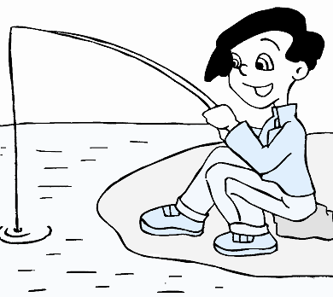____________
4. INCLUDEPICTURE "F:\\word资源\\2011x全练六年英语下人教版PEP\\QLYYRP6X30.TIF" \* MERGEFORMATINET 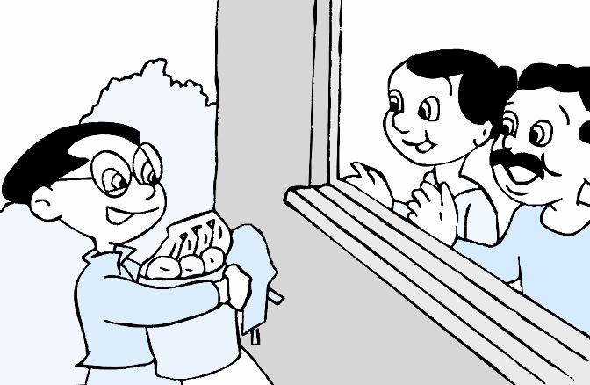____________
5. INCLUDEPICTURE "F:\\word资源\\2011x全练六年英语下人教版PEP\\ZM4.TIF" \* MERGEFORMATINET 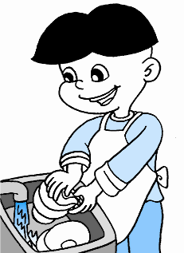____________
6. INCLUDEPICTURE "F:\\word资源\\2011x全练六年英语下人教版PEP\\放风筝4.TIF" \* MERGEFORMATINET INCLUDEPICTURE "F:\\word资源\\2011x全练六年英语下人教版PEP\\放风筝4.TIF" \* MERGEFORMATINET 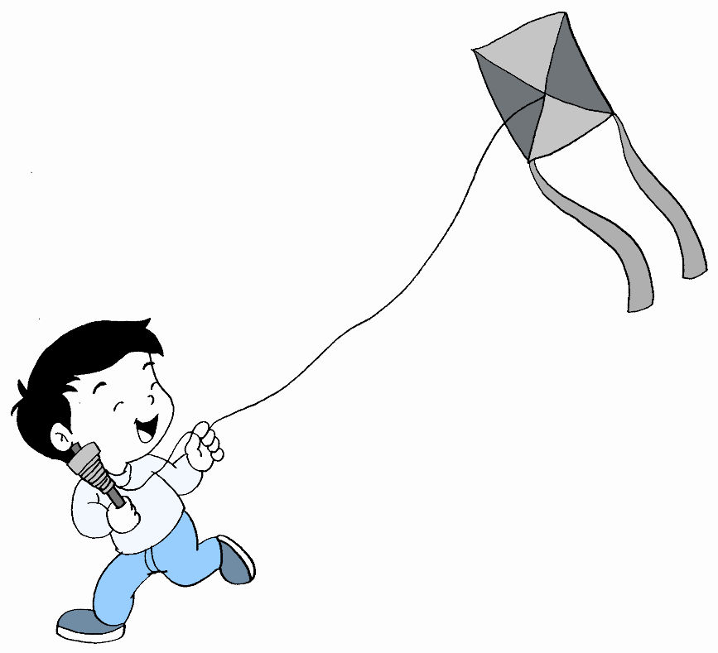____________
7. INCLUDEPICTURE "F:\\word资源\\2011x全练六年英语下人教版PEP\\T1.TIF" \* MERGEFORMATINET 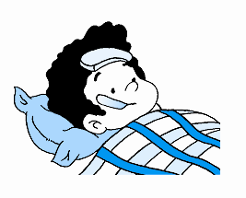____________
8. INCLUDEPICTURE "F:\\word资源\\2011x全练六年英语下人教版PEP\\ZM21.TIF" \* MERGEFORMATINET ____________
五、火眼金睛，选一选。(10分)
( )1.Mary often goes ______．
A．hike B．hiking C．hikes
( )2.______ you go to a park on the weekend?
A．Are B．Did C．Does
( )3.My mother ______ the dishes yesterday.
A．did B．do C．does
( )4.—Are there any books on the desk?
—Yes，______．
A．I am B．there are C．there is
( )5.She often ______ TV in the evening.
A．watches B．watching C．watch
( )6.I ______ to Canada last year.
A．go B．goes C．went
( )7.It ______ cloudy yesterday evening.
A．is B．was C．were
( )8.I am very grateful ______ the dog.
A．at B．of C．to
( )9.I didn't ______ a mountain last Saturday.
A．climbed B．climb C．climbing
( )10.______ did you go?
A．What B．Where C．Who
六、句子大变身。(10分)
1．I often visit my grandparents on the weekend.(用last weekend改写)
__________________________________________________________________
2．Mike watered the flowers yesterday.(改为否定句)
__________________________________________________________________
3．I have a busy weekend.(变为一般疑问句)
__________________________________________________________________
4．I watched TV last__night．(就画线部分提问)
__________________________________________________________________
5．Did Mike clean his room？(作否定回答)
__________________________________________________________________
6．yesterday，my，bike，I，rode(.)(连词成句)
__________________________________________________________________
7．Sarah goes to school on__foot．(就画线部分提问)
__________________________________________________________________
8．This is an apple.(变为复数句子)
__________________________________________________________________
9．My father is 180__cm tall.(就画线部分提问)
__________________________________________________________________
10．buy，what，you，are，going，to(？)(连词成句)
__________________________________________________________________
七、你能找出下列句子中的错误吗？找出来并改一改。(10分)
( )1.When does Alice go to school yesterday?______
A B C D
( )2.My brother like flying kites.______
A B C D
( )3.My sister have a headache.______
A B C D
( )4.he is a pupil.______
A B C D
( )5.Wu__Yifan is busy last__weekend.______
A B C D
( )6.Did you played football？______
A B C D
( )7.what do you usually do on__the__weekend?______
A B C D
( )8.Does Alice go to a park by foot？______
A B C D
( )9.John's birthday is on January.______
A B C D
( )10.The hospital is at__the__right.______
A B C D
八、填入恰当的单词，补全短文。(9分)
I have a dog 1.______ my home.It is my good friend.2.______ name is Wangwang.It has 3.______ short legs and 4.______ big ears.It 5.______ eating meat.I often do morning exercises 6.______ it.I often play with it 7.______ school.I have 8.______ friends in my school.They are Amy and Sarah.They often come to my 9.______ and play with my dog.
九、书面表达。(13分)
以“A Happy Weekend”为题写一篇小作文。
要求：1.字迹工整，语句通顺。2.不少于40个单词。
__________________________________________________________________
__________________________________________________________________
__________________________________________________________________

听力录音原文
一、1.test 2.laugh 3.skirt 4.longer 5.know
二、1.How do you feel?
2．What did you do yesterday?
3．Did you go to a park?
4．Did Alice play the piano?
5．I like the yellow dog.
三、A.He is a bad man.
B．Let's go hiking together.
C．I played football last Thursday.
D．My mother goes to work by bus.
E．Did you go swimming last Sunday?

答案全析全解
第三单元基础全练全测
一、1.watched看 2.washed洗 3.cleaned打扫
4．played玩 5.visited看望 6.did做 7.went去 8.read读；阅读
二、1.last 2.weekend 3.to 4.park 5.go swimming
6．go fishing 7.go hiking
三、1.cooked 做(饭) 2.studied 学习
四、1.C 2.E 3.A 4.D 5.B
五、1.D 2.F 3.H 4.A 5.B 6.G 7.C 8.E
第三单元综合全练全测
一、1.B 2.C 3.B 4.A 5.C
二、1.C 2.A 3.C 4.B 5.A
三、1.C 2.D 3.A 4.E 5.B
四、1.go swimming 2.wash the clothes 3.go fishing
4．visit grandparents 5.do the dishes 6.fly kites
7．have a fever 8.read a book
五、1.B 2.B 3.A 4.B 5.A 6.C 7.B 8.C 9.B 10.B
六、1.I visited my grandparents last weekend.
2．Mike didn't water the flowers yesterday.
3．Do you have a busy weekend？ 4.When did you watch TV？ 5.No，he didn't. 6.I rode my bike yesterday. 7.How does Sarah go to school?
8．These are apples. 9.How tall is your father?
10．What are you going to buy?
七、1.B did 2.B likes 3.C has 4.A He
5．B was 6.C play 7.A What 8.D on
9．C in 10.D on the right
八、1.in 2.Its 3.four 4.two 5.likes 6.with 7.after 8.two 9.home/house
九、范例：A Happy Weekend
I had a happy weekend.On Saturday I went to a zoo with my mother.I saw some animals.I like monkeys very much.They are funny.On Sunday I visited my grandparents.They cooked noodles for me.Because I like eating noodles.In the evening，I went home and played computer games.I was a little tired but I was very happy.

